Hospital Management System

Project Title
Hospital Management System Using Spring Boot and MongoDB

Objective
To develop a backend application for managing Departments, Doctors, Patients, and Appointments using Spring Boot and MongoDB.
Objectives of the Hospital Management System
•To manage patient information and records efficiently.
•To maintain doctor details and their specializations.
•To create and manage hospital departments.
•To schedule and track patient appointments with doctors.
•To store and manage patient medical records.
•To perform CRUD (Create, Read, Update, Delete) operations on all entities.
•To establish relationships between patients, doctors, departments, appointments, and medical records using MongoDB.
•To implement One-to-One, One-to-Many, Many-to-One, and Many-to-Many mappings.
•To develop RESTful APIs using Spring Boot for hospital operations.
•To integrate MongoDB for data storage and management.
•To test APIs using Postman and document them using Swagger.
•To provide a centralized system for efficient hospital administration and data management.

Tools Used and Versions
Java 21/22
Spring Boot 3.5.15
MongoDB 8.x
Maven 3.x
Postman Latest Version
Visual Studio Code Latest Version
project currently has:
✅ Spring Boot Backend
✅ MongoDB Connection
✅ Department CRUD
✅ Doctor CRUD
✅ Patient CRUD
✅ Appointment CRUD
✅ Mapping through IDs (departmentId, doctorId, patientId)
✅ Postman API Testing
✅ No frontend

Project Summary
The Hospital Management System is a backend REST API application developed using Spring Boot and MongoDB. It manages hospital data through CRUD APIs and stores records in MongoDB collections.

STRUCTURE(AS PER VSCODE):
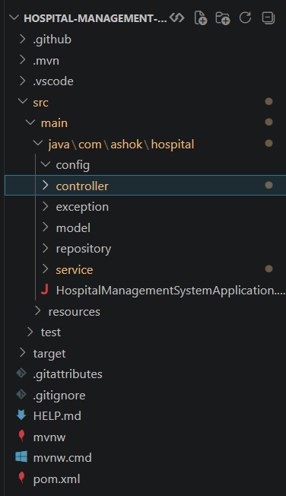
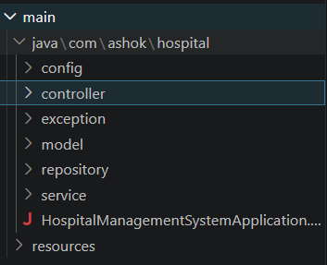

Modules Implemented
Department Module
Doctor Module
Patient Module
Appointment Module

MODEL :
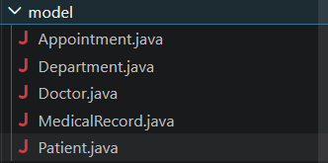
REPOSITORY :
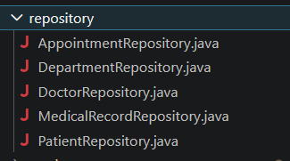
SERVICE :
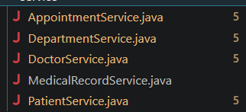
CONTROLLER :
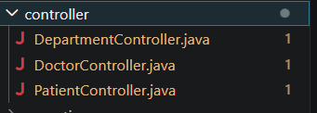

MONGODB DATABASE CONNECTION:

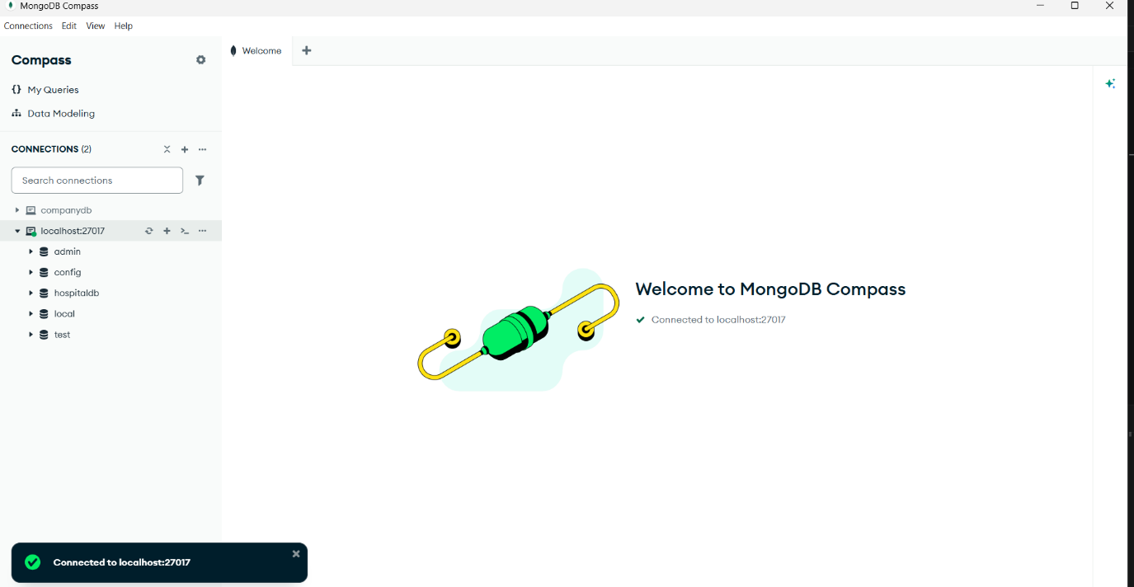
POSTMAN for TESTING:
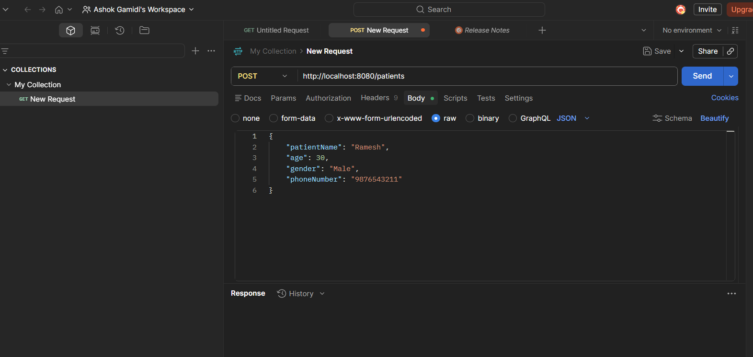

POST,GET,DELETE,PUT for testing to get details :
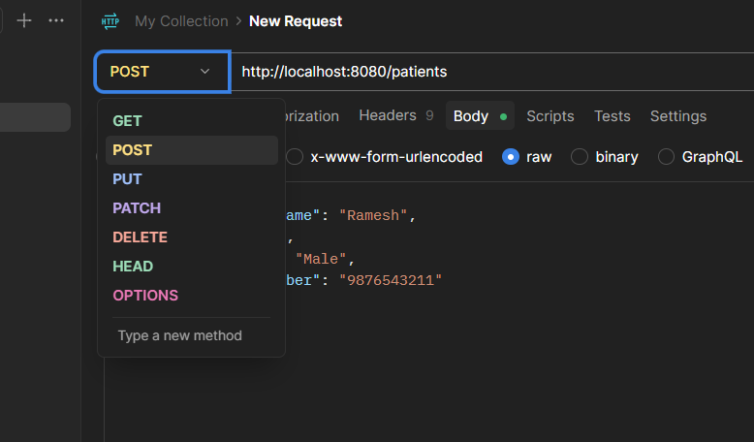
Maven handles downloading, updating, and managing all required libraries.
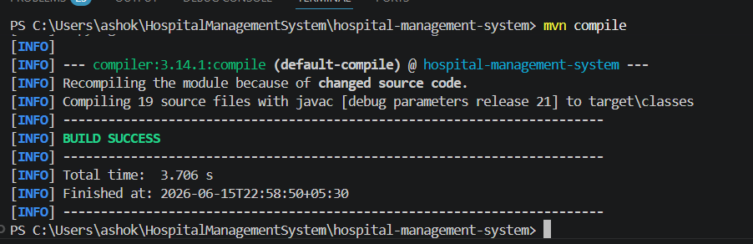
CREATING APPOINTMENT TABLE
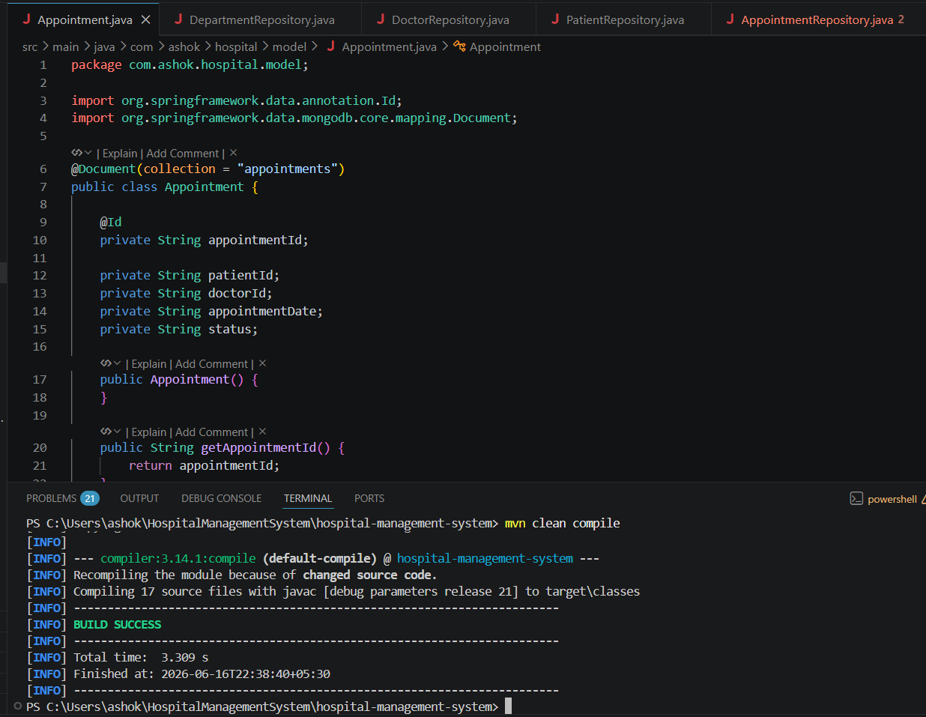
APPOINTMENT REPOSITORY
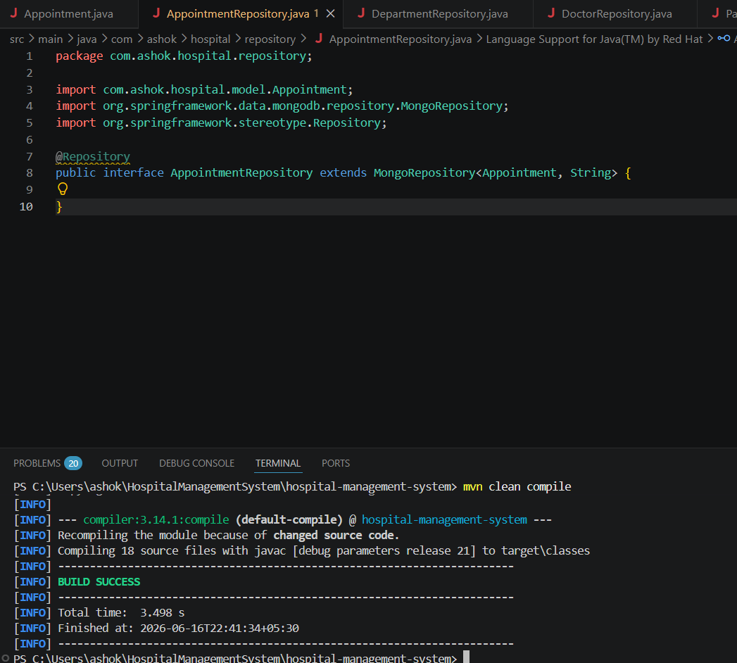

APPOINTMENT SERVICE
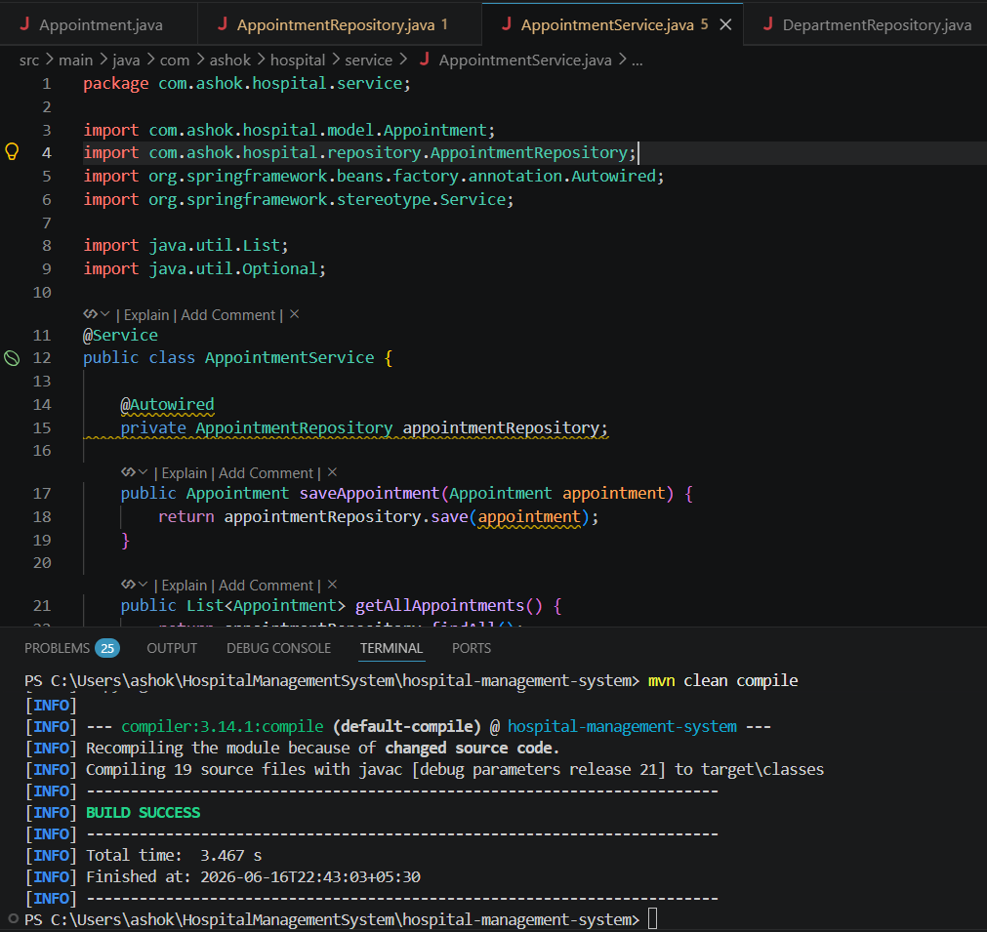
APPOINTMENT CONTROLLER
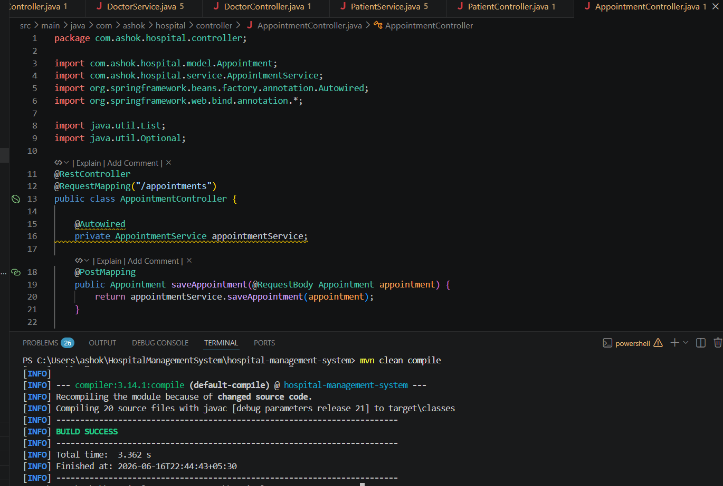

Similarly remaining modules like department ,doctor and patient are created
Lets start testing the Appointment module using the postman
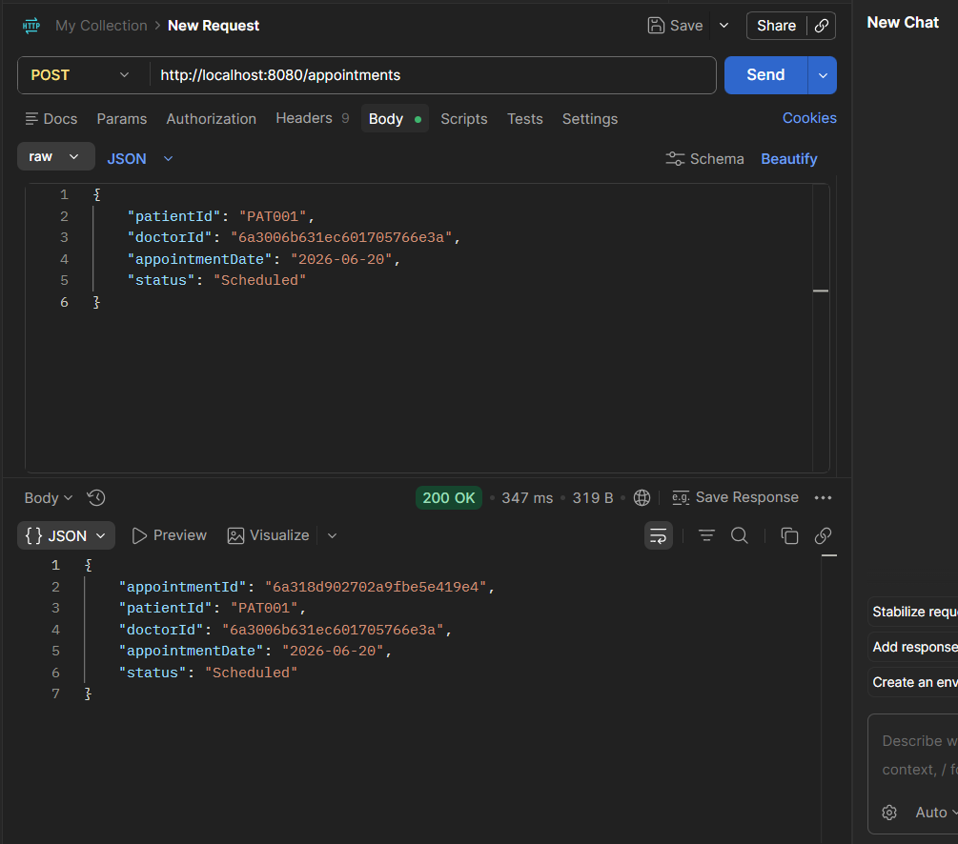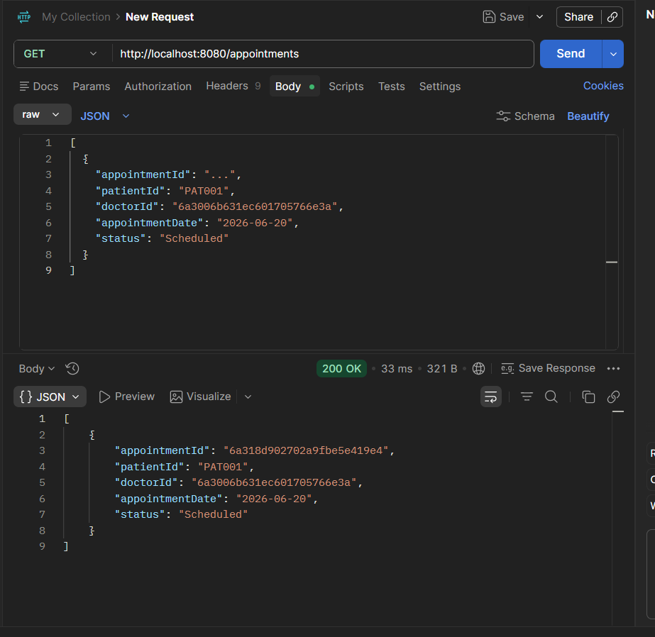
GET BY ID
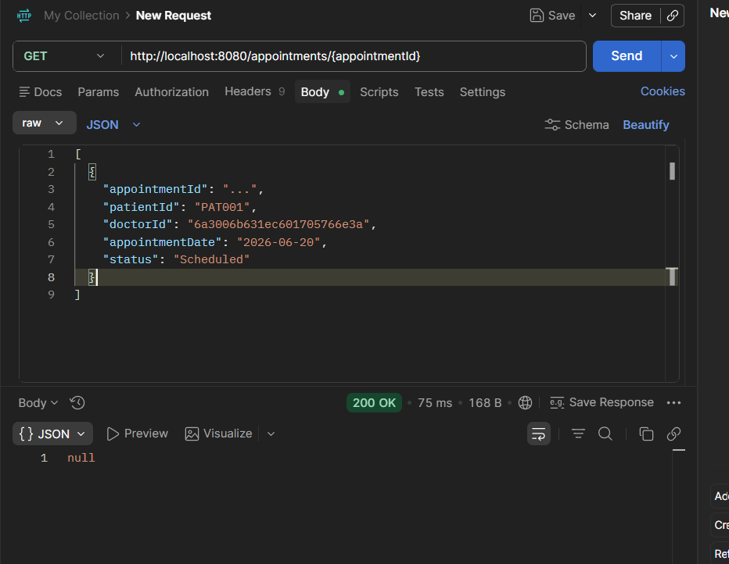

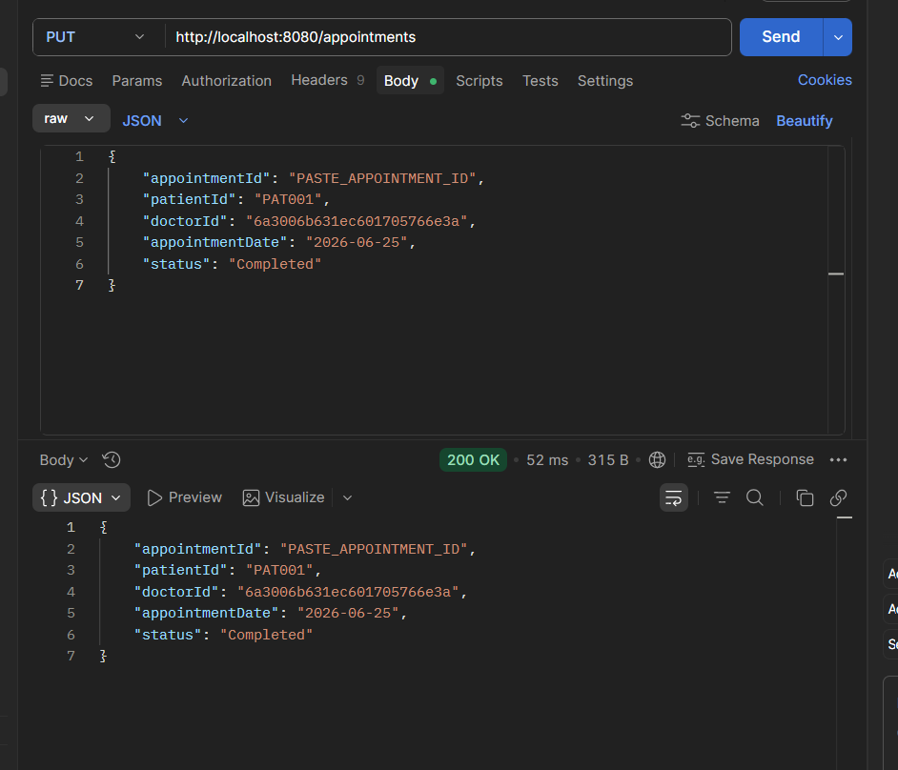
DELETE
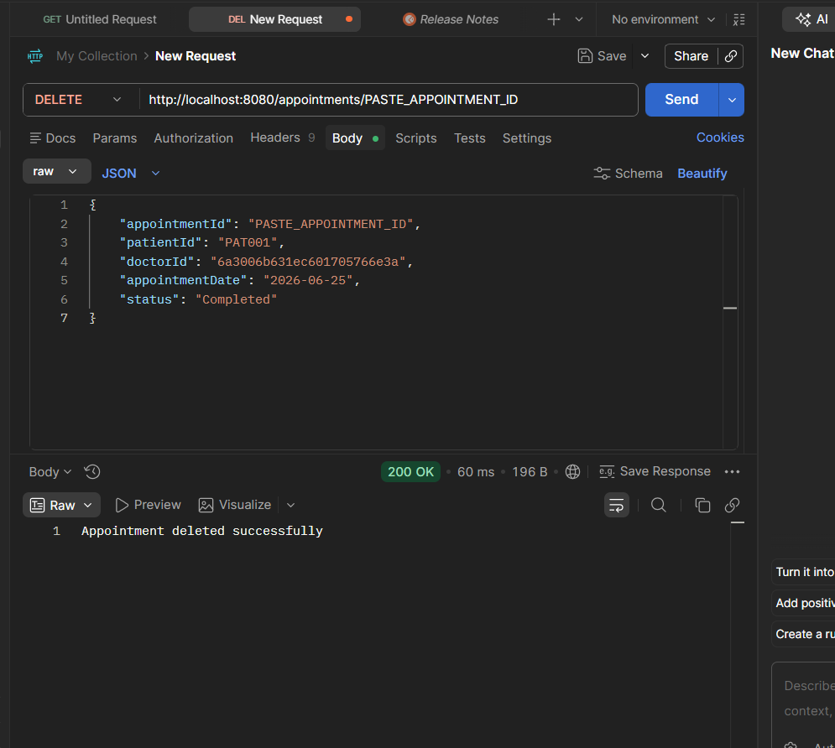

PROJECT STATUS
Nearly 75-80 percent of the project is completed.

PATIENTS TESTING
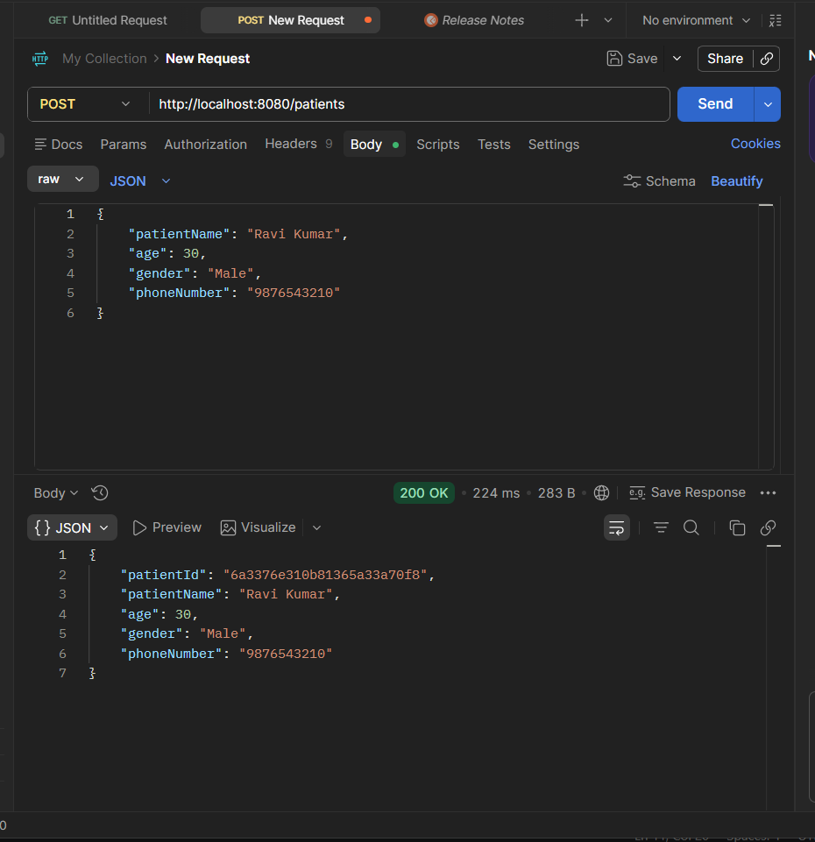
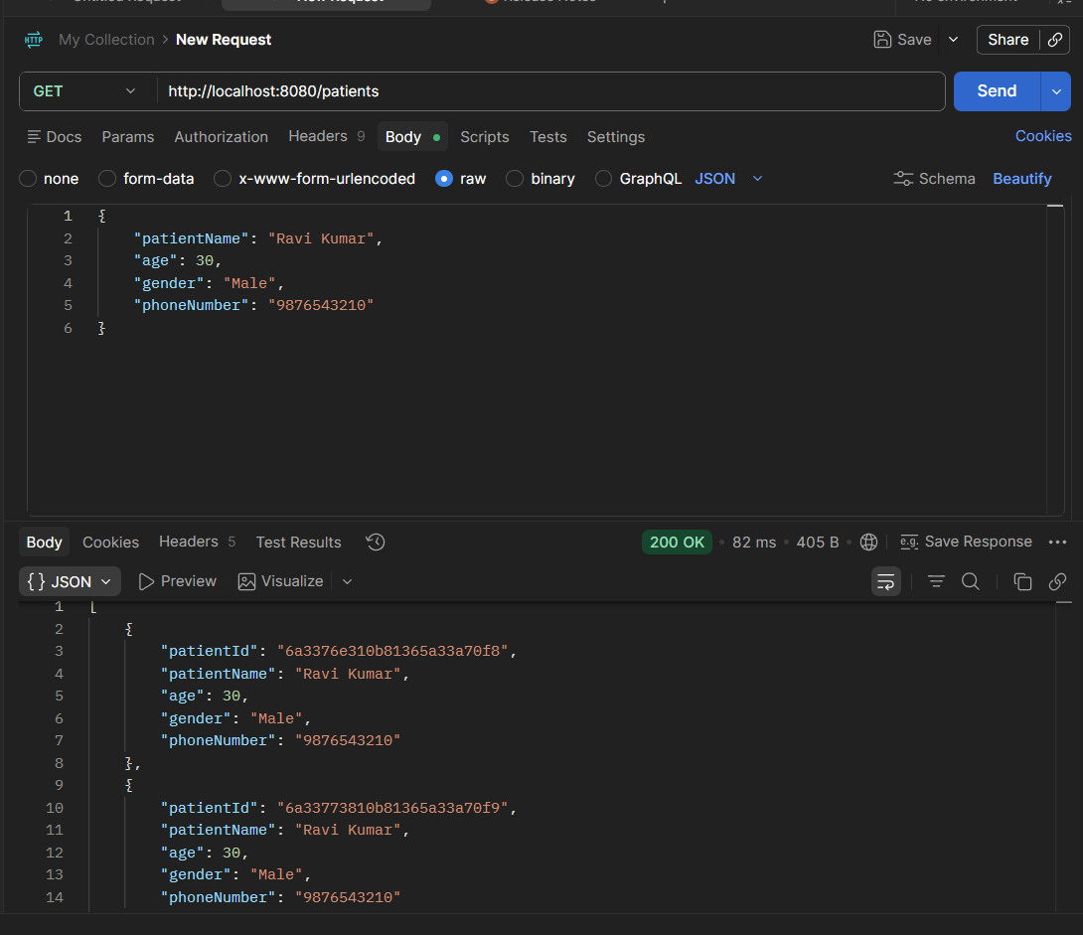
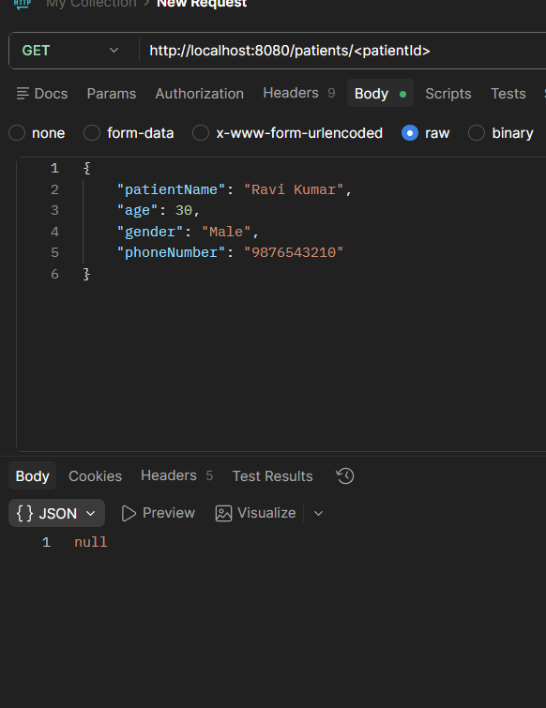
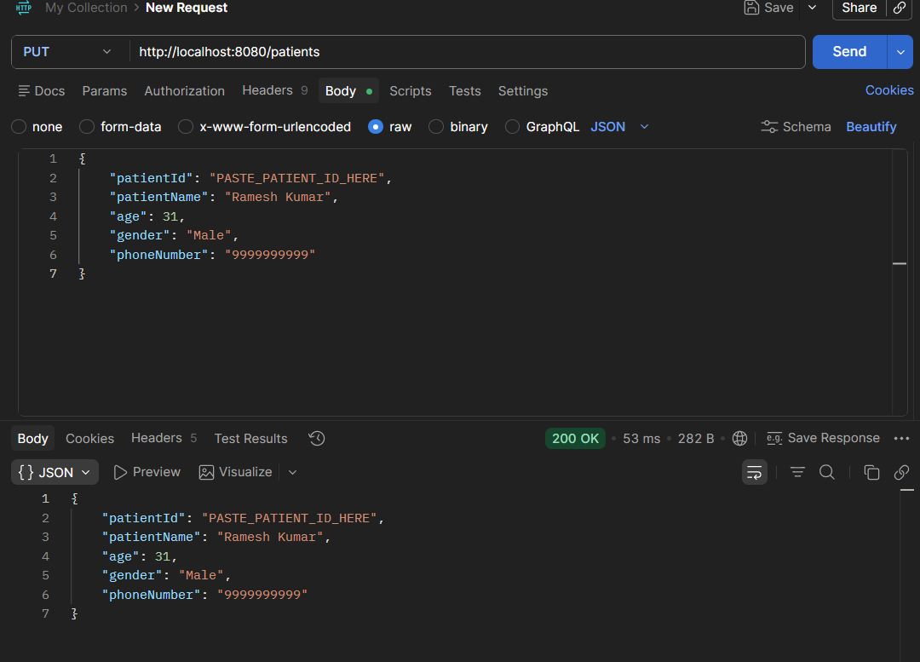
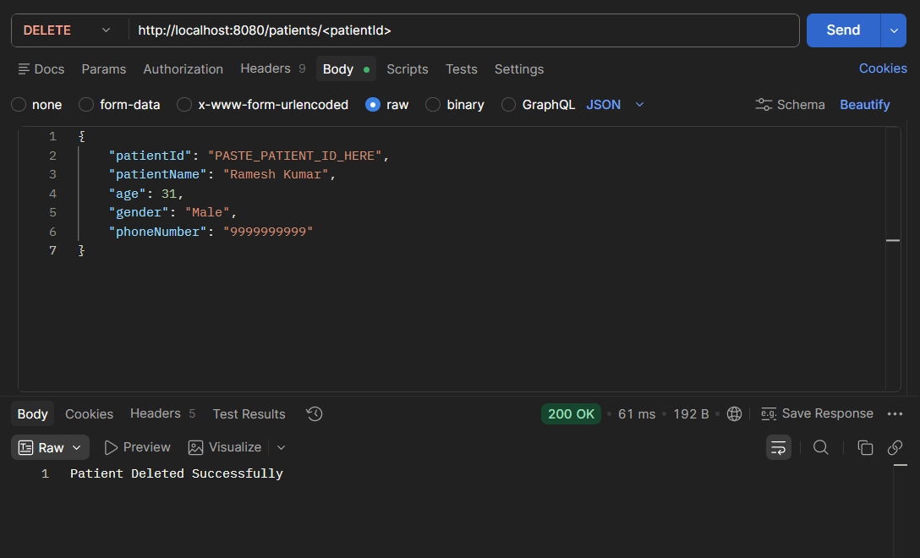

Mapping Explanation
Department -> Doctor (One-to-Many)
Doctor -> Appointment (One-to-Many)
Patient -> Appointment (One-to-Many)
Mappings are maintained using IDs.

MAPPING
One-to-One
One-to-Many
Many-to-One
Many-to-Many
Mapping 1: Department → Doctors
One Department has Many Doctors
Many Doctors belong to One Department
Example:
Cardiology
├── Dr. Rajesh
├── Dr. Kumar
└── Dr. Ravi
You already have:
private String departmentId;
inside Doctor.
So this requirement is already satisfied.
✅ One-to-Many
✅ Many-to-One

Mapping 2: Doctor → Appointments
One Doctor can have many appointments.
Example:
Dr. Rajesh
├── Appointment 1
├── Appointment 2
└── Appointment 3
In Appointment.java:
private String doctorId;
If it is already present, then this mapping is also satisfied.

Mapping 3: Patient → Appointments
One Patient can book many appointments.
Example:
Ramesh
├── Appointment 1
├── Appointment 2
└── Appointment 3
In Appointment.java add:
private String patientId;
and
private String patientName;
if not already present.

Show Faculty Example
Appointment document:
{
"appointmentId": "A101",
"doctorId": "D101",
"doctorName": "Dr. Rajesh",
"patientId": "P101",
"patientName": "Ramesh",
"appointmentDate": "2026-06-17"
}
This clearly demonstrates:
- Doctor ↔ Appointment
- Patient ↔ Appointment

API Endpoints
Departments, Doctors, Patients, and Appointments support POST, GET, PUT, and DELETE operations
- 1. Department APIs
- Create Department
- POST http://localhost:8080/departments

- Get All Departments
- GET http://localhost:8080/departments

- Get Department By ID
- GET http://localhost:8080/departments/{id}

- Example:

- GET http://localhost:8080/departments/6a2ffb3397eb715c25087bfe

- Update Department

- PUT http://localhost:8080/departments

- Delete Department
- DELETE http://localhost:8080/departments/{id}

- 2. Doctor APIs
- Create Doctor
- POST http://localhost:8080/doctors

- Get All Doctors
- GET http://localhost:8080/doctors

- Get Doctor By ID
- GET http://localhost:8080/doctors/{id}

- Update Doctor
- PUT http://localhost:8080/doctors

- Delete Doctor
- DELETE http://localhost:8080/doctors/{id}

- 3. Patient APIs
- Create Patient
- POST http://localhost:8080/patients

- Get All Patients
- GET http://localhost:8080/patients

- Get Patient By ID
- GET http://localhost:8080/patients/{id}

- Update Patient
- PUT http://localhost:8080/patients

- Delete Patient
- DELETE http://localhost:8080/patients/{id}

- 4. Appointment APIs
- Create Appointment
- POST http://localhost:8080/appointments

- Get All Appointments
- GET http://localhost:8080/appointments

- Get Appointment By ID
- GET http://localhost:8080/appointments/{id}

- Update Appointment
- PUT http://localhost:8080/appointments

- Delete Appointment
- DELETE http://localhost:8080/appointments/{id}

- Test in this order:
1.POST Department
2.GET Departments
3.POST Doctor
4.GET Doctors
5.POST Patient
6.GET Patients
7.POST Appointment
8.GET Appointments
9.UPDATE one record
10.DELETE one record

Hospital Management System
Project Overview
Hospital Management System is a Spring Boot and MongoDB based REST API application used to manage hospital operations such as Departments, Doctors, Patients, and Appointments.
The project performs CRUD operations and demonstrates entity relationships using MongoDB document references through IDs.

Technologies Used
- Java
- Spring Boot
- Spring Data MongoDB
- MongoDB
- Maven
- Postman
- VS Code

Database
Database Name: hospitaldb
Collections:
- departments
- doctors
- patients
- appointments

Modules
Department Module
- Create Department
- View Department
- Update Department
- Delete Department
Doctor Module
- Create Doctor
- View Doctor
- Update Doctor
- Delete Doctor
Patient Module
- Create Patient
- View Patient
- Update Patient
- Delete Patient
Appointment Module
- Create Appointment
- View Appointment
- Update Appointment
- Delete Appointment

Mapping Implementation
Department → Doctor
One Department can have multiple Doctors.
Relationship maintained using:
private String departmentId;
Doctor → Appointment
One Doctor can have multiple Appointments.
Relationship maintained using:
private String doctorId;
Patient → Appointment
One Patient can have multiple Appointments.
Relationship maintained using:
private String patientId;

API Endpoints
Department APIs
POST /departments
GET /departments
PUT /departments
DELETE /departments/{id}
Doctor APIs
POST /doctors
GET /doctors
PUT /doctors
DELETE /doctors/{id}
Patient APIs
POST /patients
GET /patients
PUT /patients
DELETE /patients/{id}
Appointment APIs
POST /appointments
GET /appointments
PUT /appointments
DELETE /appointments/{id}

Testing
All APIs were tested using Postman.

Conclusion
The Hospital Management System was successfully developed using Spring Boot and MongoDB. The application supports CRUD operations and demonstrates relationships between Departments, Doctors, Patients, and Appointments.

